Angular

## Built-in Directives of Angular

### Style:

* 1. It used to set the CSS property values dynamically at the runtime
  2. When the value of component property is changed, the value if css property will be automatically get changed

Syntax:

<tag [style.cssproperty]=”componentProperty”]></tag>

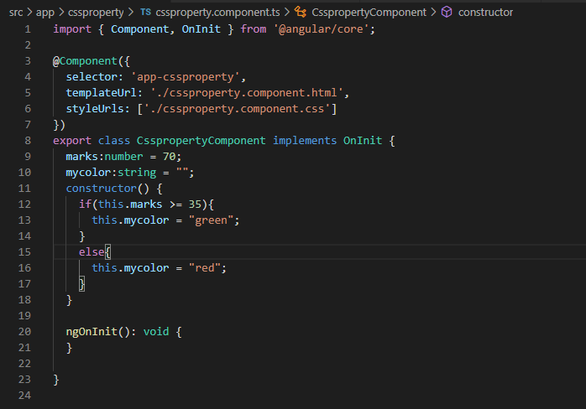

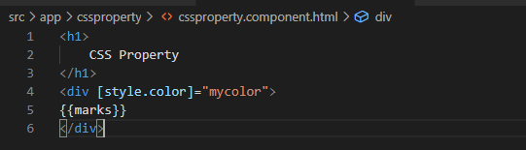

### ngClass

* 1. It is used to set the css property dynamically at runtime
  2. When the value of component property is changed, the css class will automatically changed
  3. Use this directive to set styles with multiple properties, conditionally at runtime

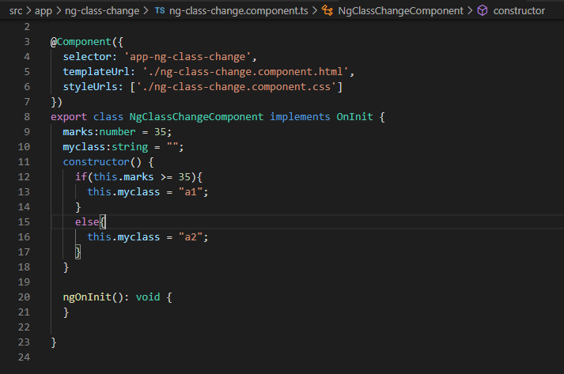

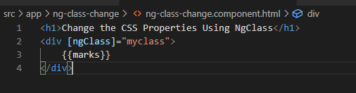

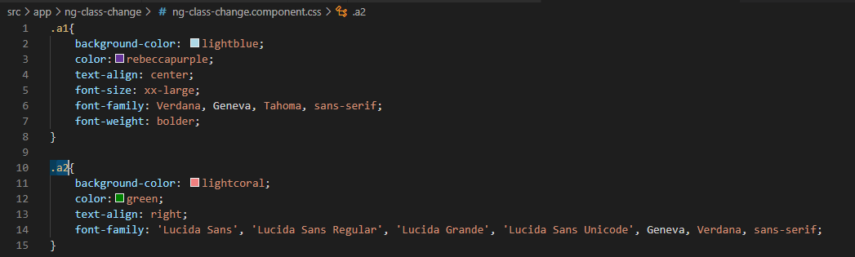

### ngIf

* 1. The “ngIf” displays the elements if the condition is “true”, otherwise the element will be deleted from the DOM(Document Object Model)

Syntax:

<tag *ngIf=”Condition”></tag>.

* 1. The ngIf must be prefixed with “*”, to mark that is accept “micro Syntax”

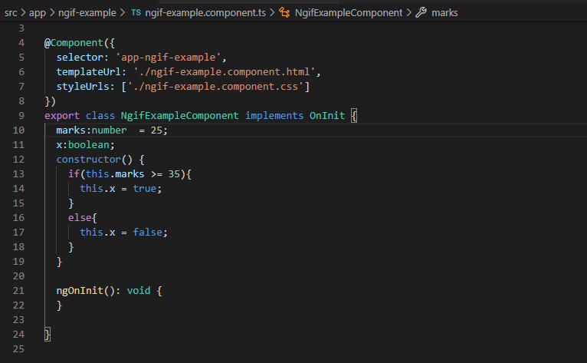

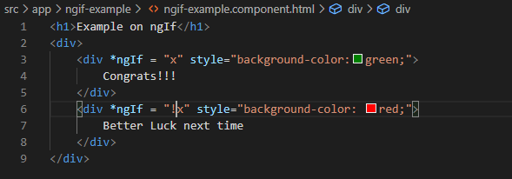

### ngIf and else

* 1. The “ngIf and else” displays one element if it is “true”, otherwise it displays another element

Syntax:

<tag *ngIf=”Condition;then template1; else template2></tag>

<ng template #template1>

……………………..

</ng template>

<ng template #ttemplate2>

………………………….

</ng template>  
 Here <ng template> is container, inside of that we can place any no.of tags

Use “ngIf and else”, if you want to display one content for the true, another content for “false” case.

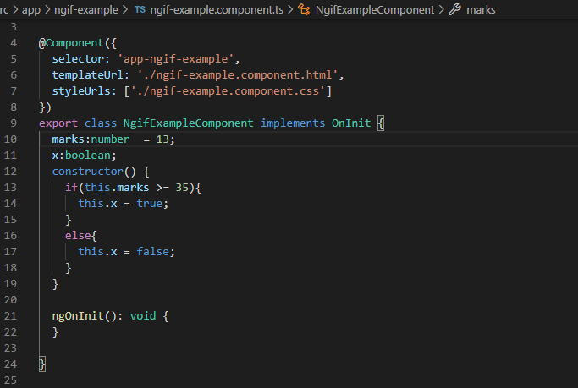

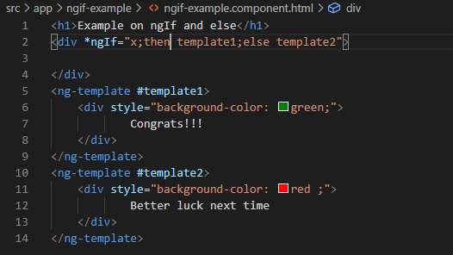

### ngFor

* 1. It is used to repeat the tag once for each element in the array. It generates the give contest once for each element of the array
  2. ngFor is also have prefix as *
  3. Example is displaying all the products in online websites

Syntax: <tag *ngFor=”let variable of arrayName”></tag>

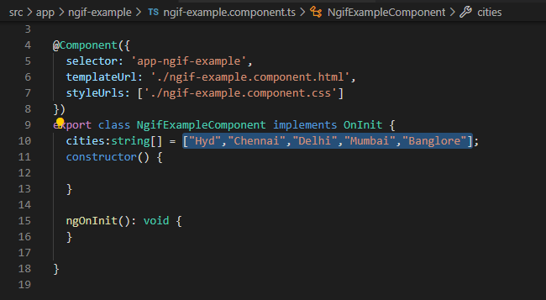

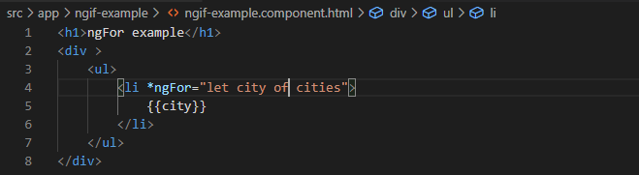

ngFor example with Array of Objects

